Evidence Output

T003:

Valid membership number.

Input number 138527.

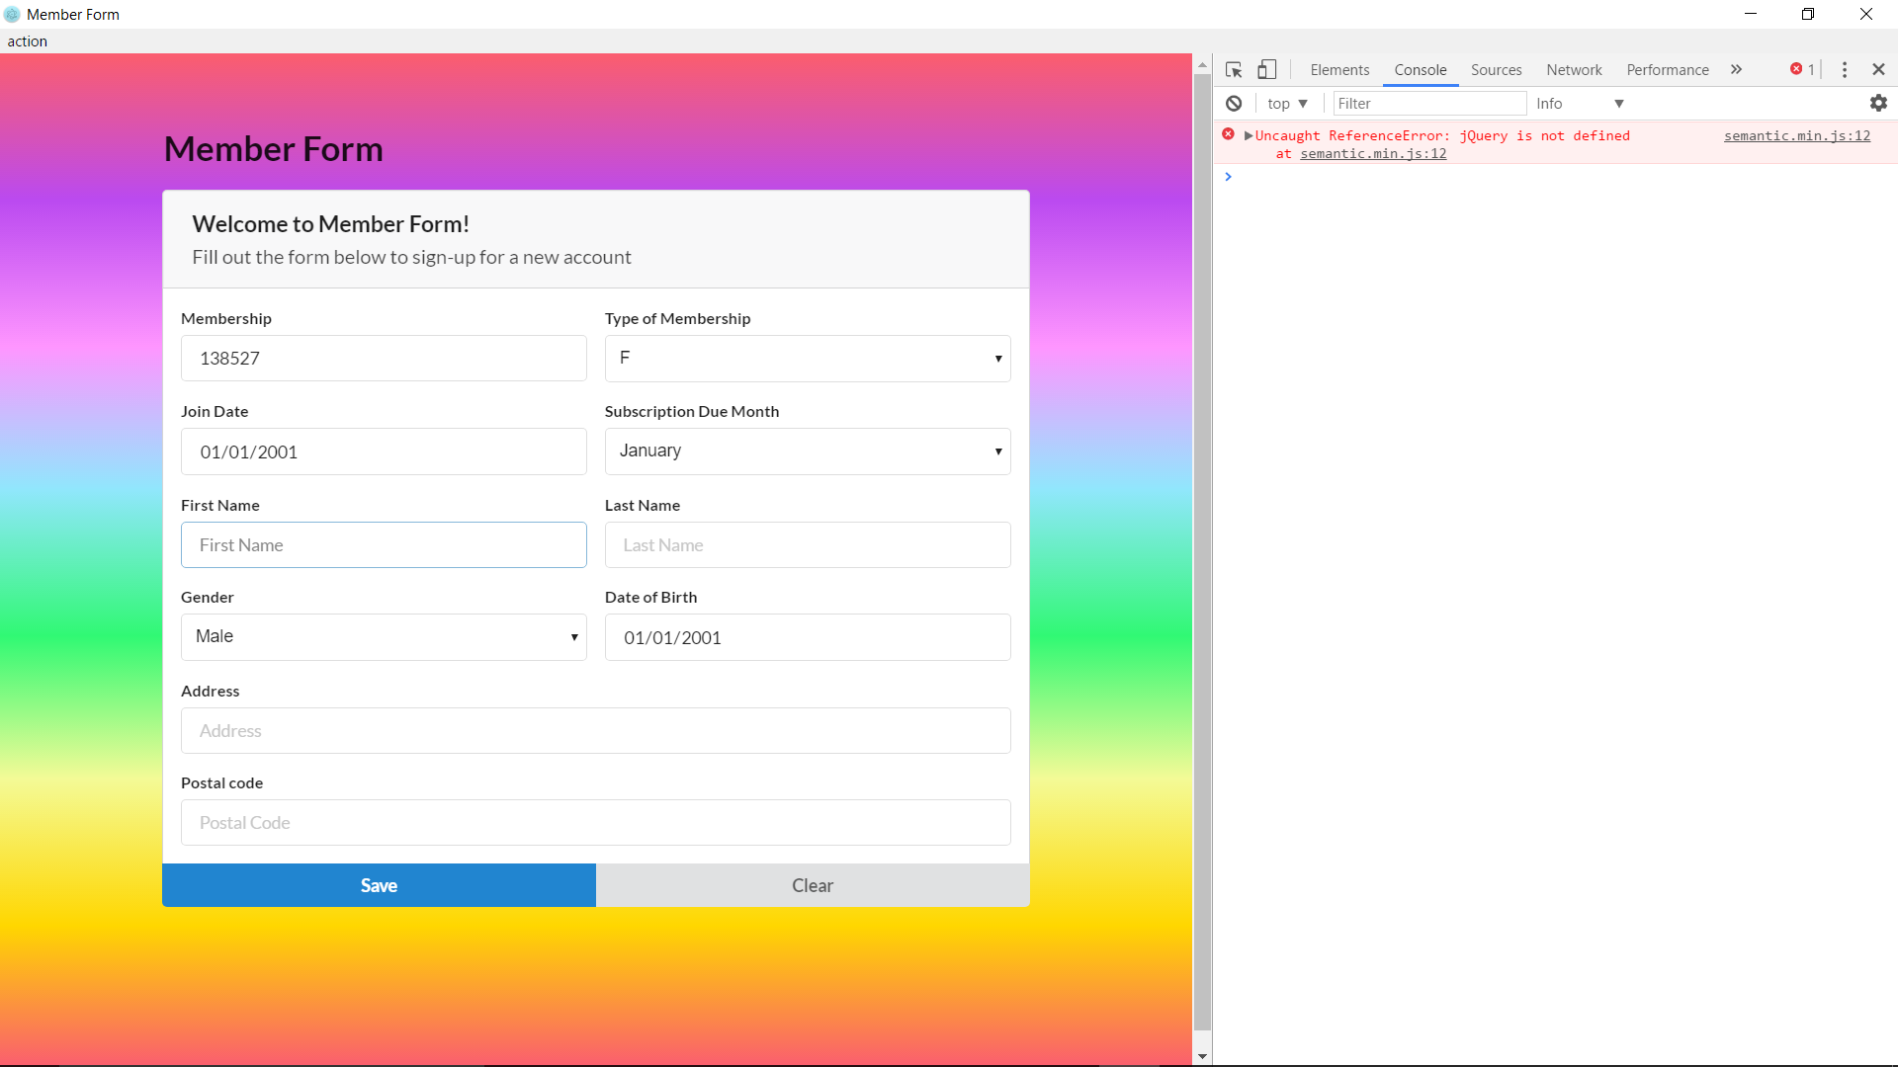

Membership number case valid 6 digits success.

